Quant Research Meeting
May 22nd, 2015 | Location: Conference Room
Agenda

Project Status

- Completed Projects
  - Update Refinancible Percentage Model (Lien)
    - Measure the PMI a borrower is currently paying
    - Capture the Pre-2005 balance using Pool level data
  - New Scale with QuantLib (Bobby)
- Combined Prepay Model and Yield Curve Builder into DLL project structure
- Merged recent changes in Yield Curve Builder into new new scale (Neo)
- In Progress Projects
  - Accordion - R project for GSE LL data model specification/estimation (Bobby)
    - Productionize Running CRT/STACR deals with eMBS CRT data ~ monthly
    - Knowledge transfer to Lien
  - Baton - R project for Agency Prepayment Modeling (Bobby)
    - Default module
  - Mortgage Rate Differences between Large Lenders and Small Lenders (Lien)
  - IOS Index Performance (Lien)
    - New 2014 bond effect
  - Follow up with YB about the current coupon difference (Lien)
    - YB value from 5/11 to 5/13 is about 0.8 bp higher than Cello’s
  - New Scale with QuantLib (Neo)
- Debugging yield curve builder interpolation error

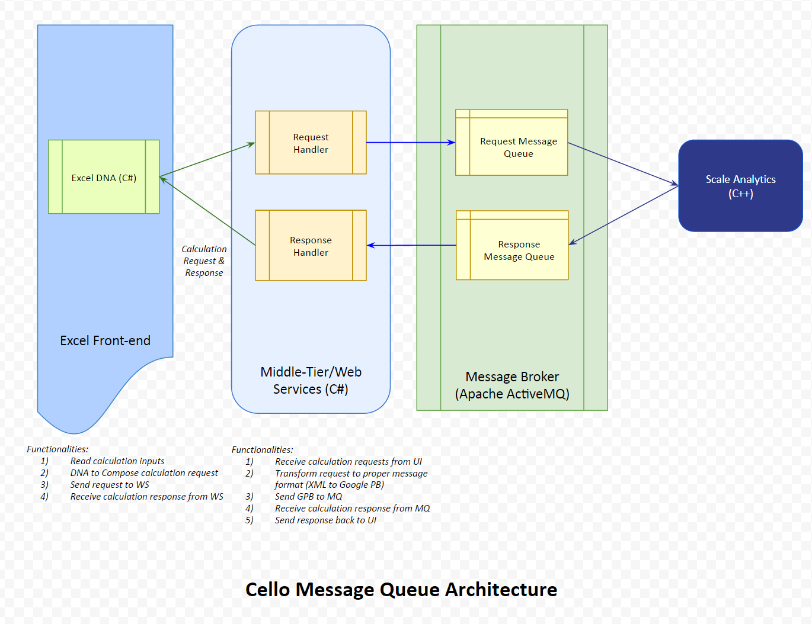

Attendees

Derek Ho, Sharad Chaudhary, Neo Wang, Lien Chen, Robert Morris

